**Assignment 1:** Program to implement Audio and Video features for your web page.

**Myprofile.html**

<!DOCTYPE html>

<html lang="en">

<head>

<meta charset="UTF-8">

<meta http-equiv="X-UA-Compatible" content="IE=edge">

<meta name="viewport" content="width=device-width, initial-scale=1.0">

<title>My Profile</title>

<link rel="stylesheet" href="./style.css">

</head>

<body>

<h1>Vikas Balu Tonde</h1>

<div align="center">

<img src="./avatar.jpg" alt="Father Image">

<table>

<tr>

<th>Date of Birth</th>

<td>21/June/1998</td>

</tr>

<tr>

<th>Occupation</th>

<td>Student</td>

</tr>

<tr>

<th>Qualities</th>

<td>

Good Sense of Humour

</td>

</tr>

<tr>

<th>Mobile number</th>

<td>

8309959743

</td>

</tr>

</table>

<audio controls>

<source src="https://dight310.byu.edu/media/audio/FreeLoops.com/1/1/20th%20Century%20Fox.mid-15132-Free-Loops.com.mp3" type="audio/mp3">

Your browser does not support the audio tag.

</audio>

<br>

<video width="320" height="240" controls>

<source src="https://www.nhc.noaa.gov/video/nhc_cone_usage.mp4" type="video/mp4">

Your browser does not support the video tag.

</video>

</div>

</body>

</html>

**Style.css**

body {

background-color: antiquewhite;

margin: 0;

padding: 0;

}

h1 {

text-align: center;

border: 5px solid black;

margin-top: 0;

margin-bottom: 5px;

margin-left: 5px;

margin-right: 5px;

padding: 5px;

background-color: aquamarine;

}

ul{

list-style: none;

}

div {

margin: 0;

border: 5px solid black;

height: 87vh;

margin-bottom: 5px;

padding: 5px;

margin-left: 5px;

margin-right: 5px;

}

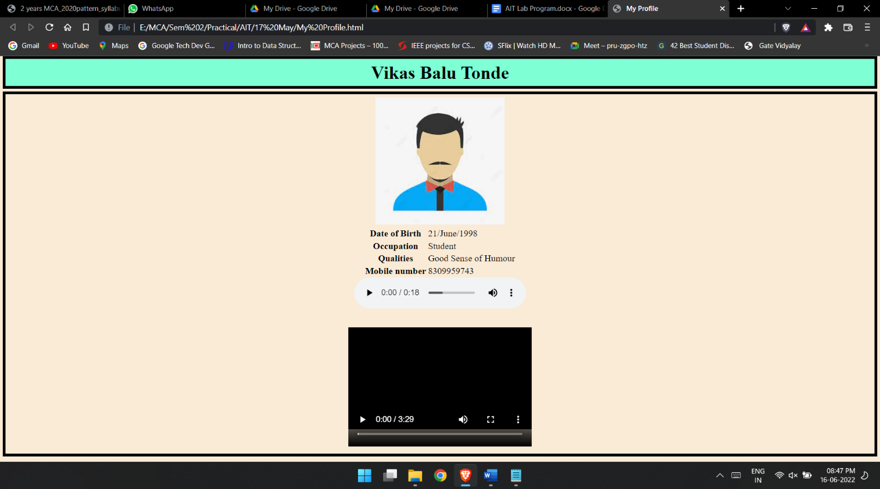

**Assignment 2:** Program to design form using HTML5 elements, attributes and Semantics.

Q2.html

<!DOCTYPE html>

<html lang="en">

<head>

<meta charset="UTF-8">

<meta http-equiv="X-UA-Compatible" content="IE=edge">

<meta name="viewport" content="width=device-width, initial-scale=1.0">

<title>Question 2</title>

<link rel="stylesheet" href="Q2.css">

</head>

<body>

<form action="" align="center" name="form" id="form">

<table align="center" name="table" id="table">

<tr>

<th>Name:</th>

<td><input type="text" name="name" id="name" required autofocus="on"></td>

</tr>

<tr>

<th>Password:</th>

<td><input type="password" id="password" name="password" required></td>

</tr>

<tr><th>Enter the mail id: </th> <td><input type="email" name="email" placeholder="abc@xyz.com" required></td></tr>

<tr>

<th>Male</th>

<td><input type="radio" value="male" name="gender"></td>

</tr>

<tr>

<th>female</th>

<td><input type="radio" value="female" name="gender"></td>

</tr>

<tr>

<th>Address:</th>

<td><Textarea rows="4" cols="40" name="address"></Textarea></td>

</tr>

<tr>

<th>Subjects:</th>

<td>

<select name="subjects" id="sub" >

<option value="null" disabled selected>Select the subject</option>

<option value="Java">Java</option>

<option value="DSA">DSA</option>

<option value="Python">Python</option>

<option value="AIT">AIT</option>

</select>

</td>

</tr>

<tr><th>Upload an image:</th><td><input type="file" name="image" accept="image/png, image/gif, image/jpeg"></td></tr>

<tr><th>Enter the data of birth:</th><td><input type="date" name="dob"></td></tr>

<tr><th>Rate your subject knowledge:</th><td><input type="range" name="knowledge" min="0" max="100"></td></tr>

<tr><th>Enter your your github profile link: </th><td><input type="url" name="github" ></td></tr>

<tr><th>Enter the marks in gradution:</th><td><input type="number" name="marks" id="marks"></td></tr>

<tr><th>Enter prefered batch timing:</th><td><input type="time" name="time" id="time"></td></tr>

<tr><td id="reset"><input type="reset" name="reset"></td> <td><input type="submit" name="submit"></td></tr>

</table>

</form>

</body>

</html>

**Q2.css**

body {

text-align: center;

align-items: center;

display: flex;

flex-direction: column;

}

th {

text-align: right;

padding-right: 15px;

}

td {

text-align: left;

padding-left: 15px;

}

table {

margin-top: 50px;

}

#reset {

text-align: right;

padding-right: 15px;

}

form {

border: 2px solid;

border-radius: 30px;

width: fit-content;

}

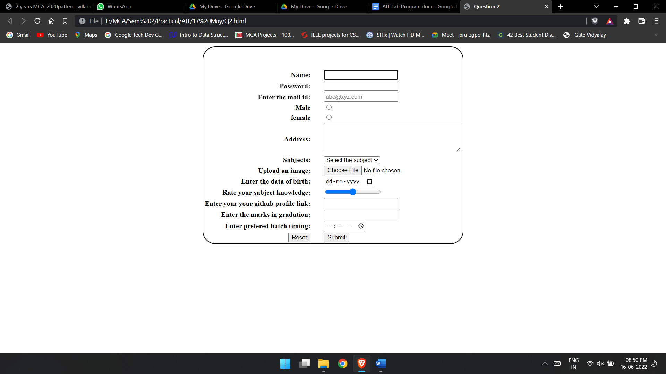

**Home.html**

<!DOCTYPE html>

<html lang="en">

<head>

<meta charset="UTF-8">

<meta http-equiv="X-UA-Compatible" content="IE=edge">

<meta name="viewport" content="width=device-width, initial-scale=1.0">

<title>All HTML elements, semantics and Attributes</title>

<link rel="stylesheet" href="./style.css">

</head>

<body>

<header class="header">

<h1 align="center">Welocome to Pune </h1>

</header>

<nav class="nav">

<a href="/" class="nav-link"><span class="nav-element">Home</span></a>

<a href="#" class="nav-link"><span class="nav-element">Contact</span></a>

<a href="#" class="nav-link"><span class="nav-element">Popular</span></a>

<a href="#" class="nav-link"><span class="nav-element">About</span></a>

</nav>

<div class="body-section">

<p class="body-text"> ipsum dolor sit amet, consectetur adipisicing elit. Illum delectus voluptas nihil, aperiam non pariatur

ipsam nisi! Aperiam porro esse, reprehenderit veniam nesciunt incidunt sit vero veritatis laborum cupiditate

soluta, itaque corporis modi laudantium et vel? Sit minus voluptas vel corrupti hic, vitae magnam, quaerat

soluta rerum, expedita eveniet quia consequuntur esse voluptatibus qui totam eaque asperiores! Molestias

accusantium modi rem, at maiores vero reprehenderit itaque voluptatibus soluta non similique quae officia

consequuntur doloremque a recusandae et fugit aspernatur animi consequatur accusamus? Temporibus, sit

veritatis. Architecto ab similique laudantium sequi iusto repellendus asperiores commodi atque ad laboriosam

perferendis, velit veniam quia provident magni minus enim error a eaque exercitationem ipsa. At pariatur

esse libero doloremque debitis quasi dignissimos, asperiores laboriosam nobis ipsa perspiciatis sed? Soluta,

praesentium voluptatem mollitia, quo voluptatum quia nam suscipit aliquam magni quae, explicabo enim quas ex

qui possimus debitis quod nobis numquam? Expedita minima explicabo quam ratione blanditiis necessitatibus

dolorum consectetur inventore harum eum nihil quibusdam reprehenderit animi neque, at eligendi et

perspiciatis sed vitae eos eaque veritatis! Omnis eum, iure quidem error quisquam, autem provident

voluptatibus voluptate nobis accusantium dicta ullam illo saepe molestiae unde quae vitae dolore quod quo

iste ad aliquid cumque odio magni. Accusamus repudiandae, labore facere beatae ex quas, corporis quis

aliquam illo fugiat necessitatibus vel eligendi porro doloribus placeat dignissimos. Tenetur in ad

excepturi, exercitationem ab repudiandae similique commodi ut molestiae! Delectus voluptatibus officiis id

ad, ratione atque asperiores magni quae qui quis dolorum voluptatem, adipisci labore, reiciendis

exercitationem non ex nisi deserunt earum quam vel! Odio numquam iure debitis officia accusantium animi

dolores impedit doloribus? Dolores sequi deserunt alias corrupti provident earum tenetur repudiandae

repellat aspernatur possimus, voluptates nulla delectus tempore porro nemo impedit nobis quaerat saepe ipsa

adipisci ut similique? Ad, possimus! Animi unde maxime voluptate, quas eveniet fuga dolorem incidunt

corporis ab numquam eius mollitia optio dolore velit sit quo. Eos asperiores modi aliquid neque ea rerum,

quas eaque eum consequuntur! Est officiis veritatis porro nesciunt. Quaerat voluptas dolorem est eaque eum

molestiae error modi ipsam, debitis nesciunt, earum cupiditate tempore alias. Voluptatem ut optio dolorem

unde voluptatibus sapiente laboriosam dolore minus quo dicta dolorum dolores maxime, eos eum placeat error

suscipit, eveniet cumque aliquid. Culpa at quas sint, sapiente nostrum doloremque nam reiciendis dicta

consectetur? Pariatur voluptatum omnis ipsa tenetur et dolorum enim praesentium voluptatibus numquam ex.

Omnis voluptas aperiam autem? Voluptas, illo veniam culpa ipsa assumenda, tempora voluptate, fugit suscipit

velit quisquam laudantium illum. Unde delectus nostrum architecto, illo sit eligendi suscipit pariatur

expedita aliquam minus nam sequi vitae earum odit laudantium hic repellat, amet iure at. Eum inventore

facilis vitae dignissimos adipisci eveniet culpa, deserunt iusto? Libero doloremque, quae ratione temporibus

eaque dolores facere vel tempora quas dolorum tenetur incidunt. Voluptate sapiente consequatur, temporibus,

quibusdam perspiciatis, velit accusantium illo incidunt qui cumque veniam sint! Unde ipsa vel numquam libero

molestias impedit omnis minus reprehenderit aliquam beatae temporibus a maiores ipsam dolores perferendis

accusantium ullam aut itaque odit facere, repudiandae deleniti? Iure velit dolore doloribus?

</p>

<div class="image-section">

<figure>

<img src="https://images.unsplash.com/photo-1477959858617-67f85cf4f1df?ixlib=rb-1.2.1&ixid=MnwxMjA3fDB8MHxzZWFyY2h8Mnx8Y2l0eXxlbnwwfHwwfHw%3D&w=1000&q=80"

alt="city1" width="100%">

<figcaption align="center">Pune city</figcaption>

</figure>

</div>

</div>

<footer class="footer">

Copyright &#169; 2022 Vikas Tonde. All rights Reserved

</footer>

</body>

</html>

**Style.css**

body{

padding: 0;

margin: 0;

}

.header{

background-color: aquamarine;

}

.nav{

background-color: black;

height: 30px;

padding: 10px;

margin-bottom: 0;

}

.nav-element{

font-size: 20px;

color: white;

margin: 10px;

margin-bottom: 0;

}

.nav-link{

cursor: pointer;

text-decoration: none;

}

.body-section{

margin-top: 0;

background-color: antiquewhite;

}

.body-text{

padding: 10px;

}

.footer{

border-top: 2px solid;

color: aquamarine;

padding: 40px;

height: 40px;

background-color: black;

text-align: center;

}

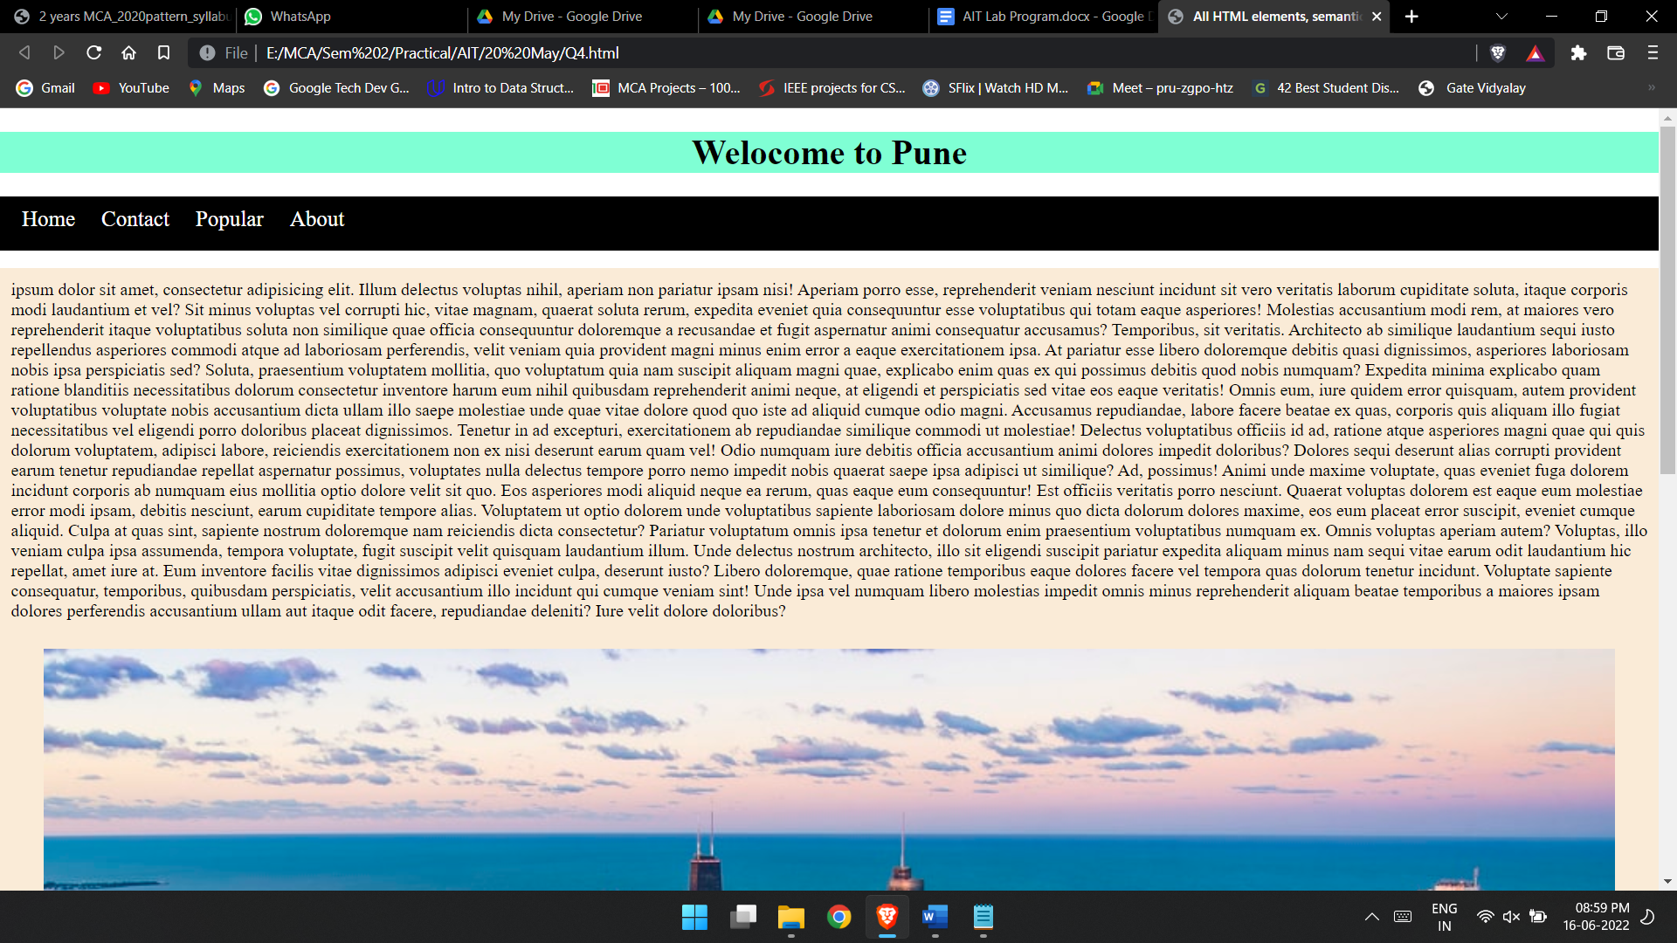

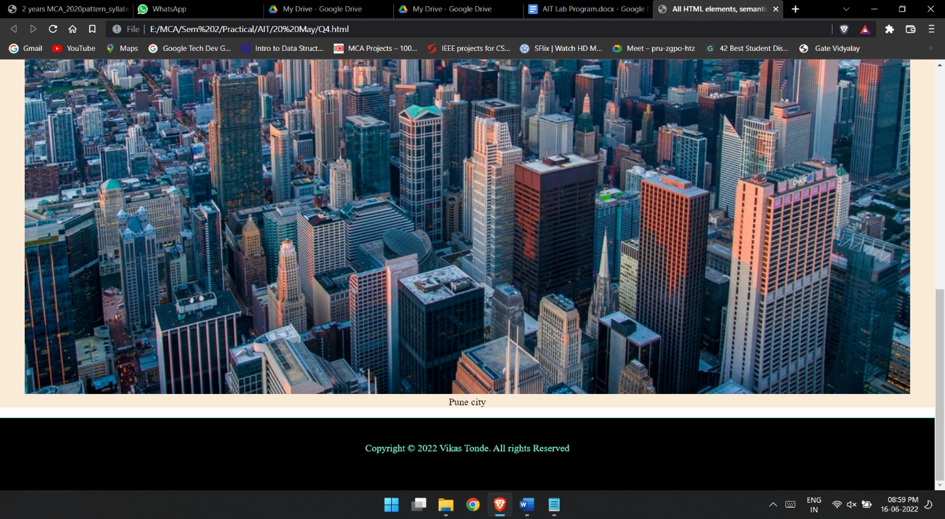

**Assignment 3:** Programs using Canvas and SVG.

SVG.html

<!DOCTYPE html>

<html lang="en">

<head>

<meta charset="UTF-8">

<meta http-equiv="X-UA-Compatible" content="IE=edge">

<meta name="viewport" content="width=device-width, initial-scale=1.0">

<title>SVG and Canvas</title>

<style>

td {

padding-left: 15px;

}

th {

padding-right: 15px;

}

</style>

</head>

<body>

<table align="center">

<tr>

<th>Square</th>

<td> <svg height="300" width="300">

<rect width="150" height="150" fill="red" />

</svg> </td>

</tr>

<tr>

<th>Rectangle</th>

<td> <svg height="300" width="300">

<rect width="300" height="150" fill="red" />

</svg> </td>

</tr>

<tr>

<th>Ellipse</th>

<td> <svg height="300" width="300">

<ellipse cx="100" cy="70" rx="85" ry="55" fill="red" />

<text fill="#ffffff" font-size="45" font-family="Verdana" x="50" y="86">SVG</text>

</svg> </td>

</tr>

<tr>

<th>Star</th>

<td> <svg height="300" width="300">

<polygon points="100,10 40,198 190,78 10,78 160,198" fill="red" stroke="blue" stroke-width="3px" />

</svg> </td>

</tr>

<tr>

<th>Circle</th>

<td> <svg height="300" width="300">

<circle cx="100" cy="100" r="90" stroke="black" fill="red" />

</svg> </td>

</tr>

</table>

</body>

</html>

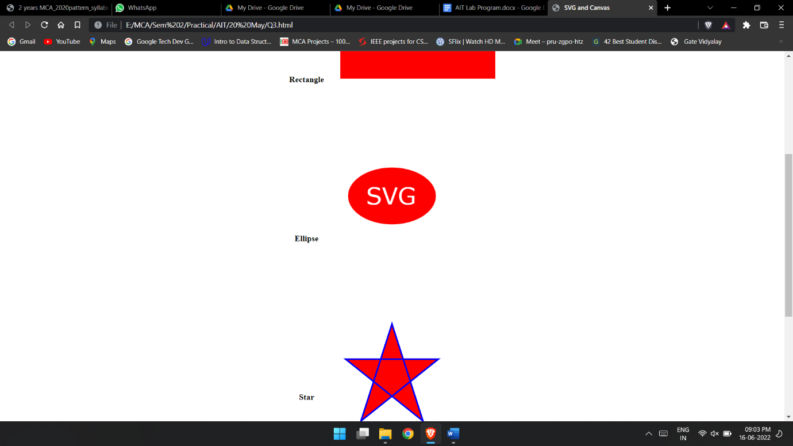

**Assignment 4:** Programs to demonstrate external and internal styles in the web page using font, text, background, borders, opacity and other CSS 3 properties.

Perform following Css properties

body background color = brown

marquee for color = yellow

Font size = 12, color = maroon, name = Arial,Italic, Anchor active='red'

visited = 'blue', current = 'green'

Display Text in italic.

scroll & Fixed background image

Background color of H2 as blue & H3 as green

underline & overline text

display background image horizontally & vertically

text having background image

table rows with different color.

**Home.html**

<!DOCTYPE html>

<html lang="en">

<head>

<meta charset="UTF-8">

<meta http-equiv="X-UA-Compatible" content="IE=edge">

<meta name="viewport" content="width=device-width, initial-scale=1.0">

<title>Implement CSS</title>

<link rel="stylesheet" href="./style.css">

</head>

<body>

<header id="Assignment1">

<h1>Assignment 1</h1>

<marquee class="MarqueExample">Lorem ipsum dolor sit amet, consectetur adipisicing elit. Porro accusantium voluptatum dolore nesciunt hic error quo facilis aliquid iure consequatur quidem culpa facere ea quae natus quod earum, rem cumque!</marquee>

</header><div id="Assignment2">

<a href="E:\MCA\HTML\FormValidation.html" class="text" >To view Other Files Click Here</a>

</div>

<div id="Assignment3">

<p>Lorem ipsum dolor sit amet consectetur adipisicing elit. Consequuntur hic eaque quisquam laudantium tempora esse voluptatibus ipsam dignissimos incidunt, quod vitae libero enim repellendus?</p>

</div>

<div id="Assignment4">

<h2 class="bcolor">Heading With H2</h2>

<h3 class="bcolor">Heading With H3</h3>

</div>

<div id="Assignment5">

<p class="UderlineExample">Lorem ipsum dolor sit amet consectetur adipisicing elit. Architecto beatae debitis hic commodi harum vero, assumenda adipisci officiis alias atque nemo consequatur corrupti molestias optio nihil. Necessitatibus, suscipit deleniti qui omnis asperiores est quos itaque aperiam commodi cupiditate doloribus rerum magnam natus quod dicta ipsum perferendis molestiae deserunt saepe perspiciatis. Lorem ipsum dolor sit amet, consectetur adipisicing elit. Ullam, sit laboriosam. Ullam exercitationem autem qui rerum nobis sequi laudantium explicabo.</p>

<p class="OverlineExample">Lorem ipsum dolor sit amet, consectetur adipisicing elit. Ullam, sit laboriosam. Ullam exercitationem autem qui rerum nobis sequi laudantium explicabo.</p>

</div>

<div id="Assignment6">

<p>Lorem ipsum dolor, sit amet consectetur adipisicing elit. Eos totam doloremque delectus debitis. Quas quisquam facilis, quis id dolorem suscipit! Esse nulla cupiditate commodi laboriosam nihil exercitationem, placeat dolore voluptatum odit accusamus unde quidem, porro vel nam asperiores nesciunt dolorem cum sunt!</p></div>

<div>

<table class="table"> <tr>

<th>Name</th>

<th>Birth Year</th>

<th>Email</th>

</tr> <tr>

<td>Vikas</td>

<td>21/06/2000</td>

<td>vikas@gmail.com</td>

</tr> <tr>

<td>Rajeev</td>

<td>27/02/2000</td>

<td>rajeev@gmail.com</td>

</tr>

<tr>

<td>Khushboo</td>

<td>06/01/1999</td>

<td>khushboo@gmail.com</td>

</tr>

</table>

</div>

</body>

</html>

**Style.css**

#Assignment1{

background-color: brown;

}

#Assignment1 .MarqueExample{

color: yellow;

}

#Assignment2 .text{

font-size: 12px;

color: maroon;

font-family: Arial, Helvetica, sans-serif;

font-style: italic;

}

#Assignment2 a:active {

color: red

}

#Assignment2 a:visited{

color: blue;

}

#Assignment2 a:current{

color: green;

}

#Assignment3{

font-style: italic;

}

#Assignment4 h2{

background-color: blue;

}

#Assignment4 h3{

background-color: green;

}

#Assignment5 .UderlineExample{

text-decoration: underline;

}

#Assignment5 .OverlineExample{

text-decoration: overline;

}

#Assignment5{

background: url('./back.jpg');

background-repeat: repeat-x;

}

#Assignment6{

background: url('./familypic.jpg');

background-repeat: repeat-y;

color: yellow;

}

tr:nth-child(even) {background: rgb(249, 69, 255)}

tr:nth-child(odd) {background: rgb(29, 216, 160)}

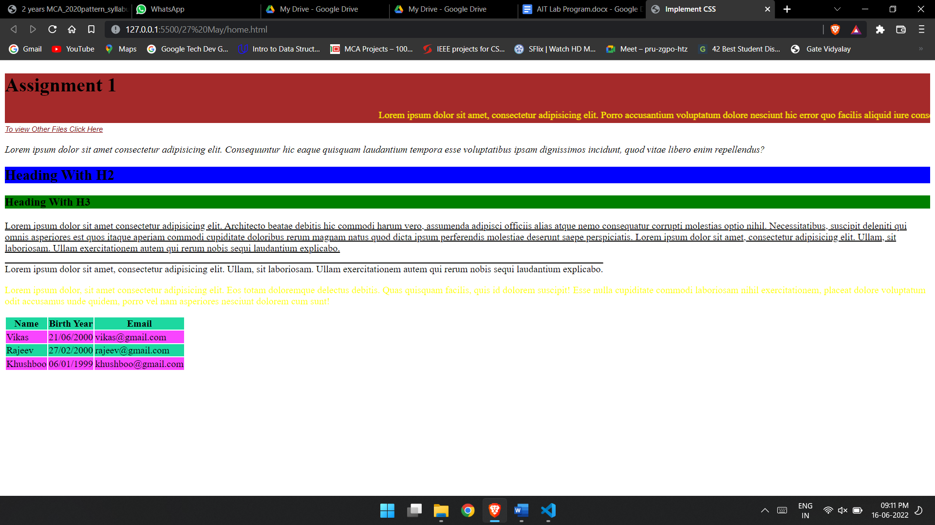

**Lightbill.html**

<!DOCTYPE html>

<html lang="en">

<head>

<meta charset="UTF-8">

<meta http-equiv="X-UA-Compatible" content="IE=edge">

<meta name="viewport" content="width=device-width, initial-scale=1.0">

<title>Electricity Bill</title>

<link rel="stylesheet" href="./style.css">

</head>

<body>

<header>

<div class="logo">

<img src="https://www.mahadiscom.in/wp-content/uploads/2017/12/logo_main.jpg" alt="logo">

<h1>Maharashtra State Electricity Distribution Co. Ltd.</h1>

</div>

</header>

<main class="table">

<div class="note">

<p>Note: While Saving printing the bill in . PDF format please tick background graphics option and margins to none in more settings. <input type="button" value="Print / Download"></p>

</div>

<div class="date">

<h4>Veej Purvadha Deyak AAhe May: 2022</h4>

</div>

<div class="address">

<div>

<div class="website">

Website: www.mahadiscom.in

</div>

<div class="addressSample"> Lorem, ipsum dolor sit amet consectetur <br>

adipisicing elit. Debitis, maxime!

</div>

</div>

<div>

HSN code 2716000

</div>

</div>

<hr />

<div class="kramanka">

<div>

Grahak Kramanka: 160221072712 <br>

Mrs. RUKMINI DEVI

<div class="addre"> Lorem ipsum dolor sit, amet consectetur adipisicing elit. Aperiam consequuntur quae <br> officiis mollitia! Assumenda hic molestiae quaerat officia

</div>

</div>

<div class="boxes">

<div class="box">

<div class="boxing">

<div>Due Date </div>

<div>09-MAY-22</div>

</div>

<div class="boxing">

<div>Due Amount </div>

<div>4,750.00</div>

</div>

</div>

<div class="box">

<div class="boxing">

<div>Due Date </div>

<div>09-MAY-22</div>

</div>

<div class="boxing">

<div>Due Amount </div>

<div>4,750.00</div>

</div>

</div>

</div>

</div>

<hr>

<div class="middle">

<div>

<div class="InnerMiddle">

<div class="left"> Lorem ipsum dolor sit amet consectetur adipisicing elit. <br>

Sed architecto voluptates recusandae accusamus ullam placeat <br>

odio nam voluptatum veniam tenetur! <br>

</div>

<div class="center"> Lorem ipsum dolor sit, amet consectetur adipisicing elit. <br>

Exercitationem temporibus facilis odit, tempora laboriosam assumenda! <br>

</div>

</div>

<div>

<div class="btnContainer">

<div class="btn">Current Reading</div>

<div class="btn">Previous Reading</div>

<div class="btn">MF</div>

<div class="btn">Unit</div>

<div class="btn">Adj Unit</div>

<div class="btn">Total</div>

<div class="btn">15109</div>

<div class="btn">15022</div>

<div class="btn">01</div>

<div class="btn">88</div>

<div class="btn">0</div>

<div class="btn">86</div>

</div>

</div>

<div class="meter"> Lorem ipsum dolor sit amet consectetur, adipisicing elit. Voluptatibus, aspernatur in voluptate enim assumenda culpa face

</div>

</div>

<div class="box">

<div class="scan">

<div class="scannerText"> Scan This QR Code with BHIM App for UPI Payment

</div>

<div class="ScannerImage">

<img src="data:image/png;base64"

alt="scanner" width="60px">

</div>

</div>

<div class="normalText">Lorem ipsum dolor sit amet, consectetur adipisicing elit. In, magnam? Lorem ipsum dolor sit.

</div>

</div>

</div>

<hr>

<div class="maincontain">

<div class="kramanka">

<div class="barImage">

<img src="./bar.PNG" width="1030px" alt="bar" srcset="">

</div>

<div class="box1">

<div class="text">

Lorem ipsum dolor sit amet consectetur adipisicing elit. Libero illo doloribus

praesentium vero, autem iusto molestiae. Dicta doloremque obcaecati consequatur.

</div>

</div>

</div>

<div class="bigBox">

<h4>Special Message:</h4>

<ul>

<li>Consumers can pay electricity bill online through MSEDCL official website www.mahadis com.in and through MAHAVITARAN Mobile App without any extra charges. Consumers will not be charged any extra charges for electricity bill payments made through Net banking. UPI, Debit card, Digital wallet and Cash cards.

</li> <li> MSEDCL has started facility to give information of meter reading through SMS on registered mobile number of the consumers after meter reading taken. Consumer can view the photo of meter reading on Consumer Portal of MSEDCL

</li> </ul></div>

</div>

<hr> <div class="middle1"> <div>

<div class="row"> <div class="data">

Billing Unit

</div>

<div class="data">

4745

</div> <div class="data">

Customer No &nbsp;

</div> <div class="data">

170000043790

</div> <div class="data">

PC:

</div> <div class="data">

2

</div> <div class="data">

Tariff:

</div> <div class="data">

092

</div>

</div> <div class="row">

<div class="data1">

Due Date

</div>

<div class="data1">

10-Jun-19

</div> <div class="data1">

590

</div> </div>

</div> <div>

<div class="row">

<div class="data2">

Paid By this date

</div> <div class="data2">

10-Jun-19

</div> <div class="data2">

590.00

</div> </div>

<div class="row">

<div class="data2">

Paid By this date

</div> <div class="data2">

31-Jul-19

</div> <div class="data2">

620.00

</div> </div> </div> </div>

<hr>

<div class="middle1">

<div> <div class="row">

<div class="data1">

Bank Copy

</div> <div class="data1">

DTC No

</div> <div class="data1">

4745885

</div>

</div> <div class="row">

<div class="data">

Billing Unit

</div>

<div class="data">

4745

</div> <div class="data">

Customer No &nbsp;

</div> <div class="data">

170000043790

</div> <div class="data">

PC:

</div> <div class="data">

2

</div> <div class="data">

Tariff:

</div> <div class="data">

092

</div> </div> </div>

<div> <div class="row">

<div class="data2">

Due Date

</div> <div class="data2">

10-Jun-19

</div> <div class="data2">

10-Jun-19

</div> </div>

<div class="row">

<div class="data2">

Paid By this date

</div> <div class="data2">

10-Jun-19

</div> <div class="data2">

590.00

</div></div>

<div class="row">

<div class="data2">

Paid After this date

</div> <div class="data2">

31-Jul-19

</div> <div class="data2">

620.00

</div> </div> </div> </div> </main>

</body>

</html>

**Style.css**

body{

box-sizing: border-box;

height: 100%;

}

.logo{

display: flex;

justify-content: center;

align-items: center;

flex-direction: column;

}

.table{

margin: 0 100px 100px 100px;

border: 1px solid #000;

padding: 0 20px;

}

.note{

text-align: center;

}

.date{

padding-top: 10px;

text-align: center;

}

.address{

display: flex;

justify-content: space-between;

}

.website{

font-weight: bold;

}

.kramanka{

display: flex;

justify-content: space-between;

}

.boxes{

display: flex;

flex-direction: column;

}

.box{

background-color: rgb(255,179,179);

padding: 5px;

margin-bottom: 5px;

}

.boxing{

width: 200px;

display: flex;

justify-content: space-between;

}

.middle{

display: flex;

flex-direction: row;

justify-content: space-between;

background: rgb(255,236,255);

}

.InnerMiddle, .scan{

display: flex;

flex-direction: row;

}

.scannerText{

width: 140px;

}

.left, .center{

width: 430px;

}

.btn{

background: linear-gradient(rgb(247, 255, 234), rgb(154, 255, 60));;

padding: 5px 18px;

margin: 2px;

border-radius: 10px;

border: 1px solid #000;

box-shadow: 1px 3px 3px #000;

height: 42px;

width: 12%;

font-size: 19px;

}

.btnContainer{

display: flex;

flex-wrap: wrap;

margin-top: 5px;

text-align: center;

}

.normalText{

width: 140px;

}

.meter{

width: 240px;

margin: 10px;

}

.text{

width: 200px;

}

.box1{

background-color: rgb(251,198,214);

padding: 5px;

}

.bigBox{

margin: 0;

border-top: 5px solid #fff;

background-color: rgb(251,198,214);

}

.maincontain{

display: flex;

flex-direction: column;

}

table{

display: table;

width:auto;

background-color:#eee;

border:1px solid #666666;

border-spacing:5px;

}

.middle1, .row{

display: flex;

margin: 5px;

}

.data, .data1, .data2{

border: 1px solid #000;

padding: 2px 20px;

}

.data1{

width: 202px;

}

.data2{

width: 110px;

}

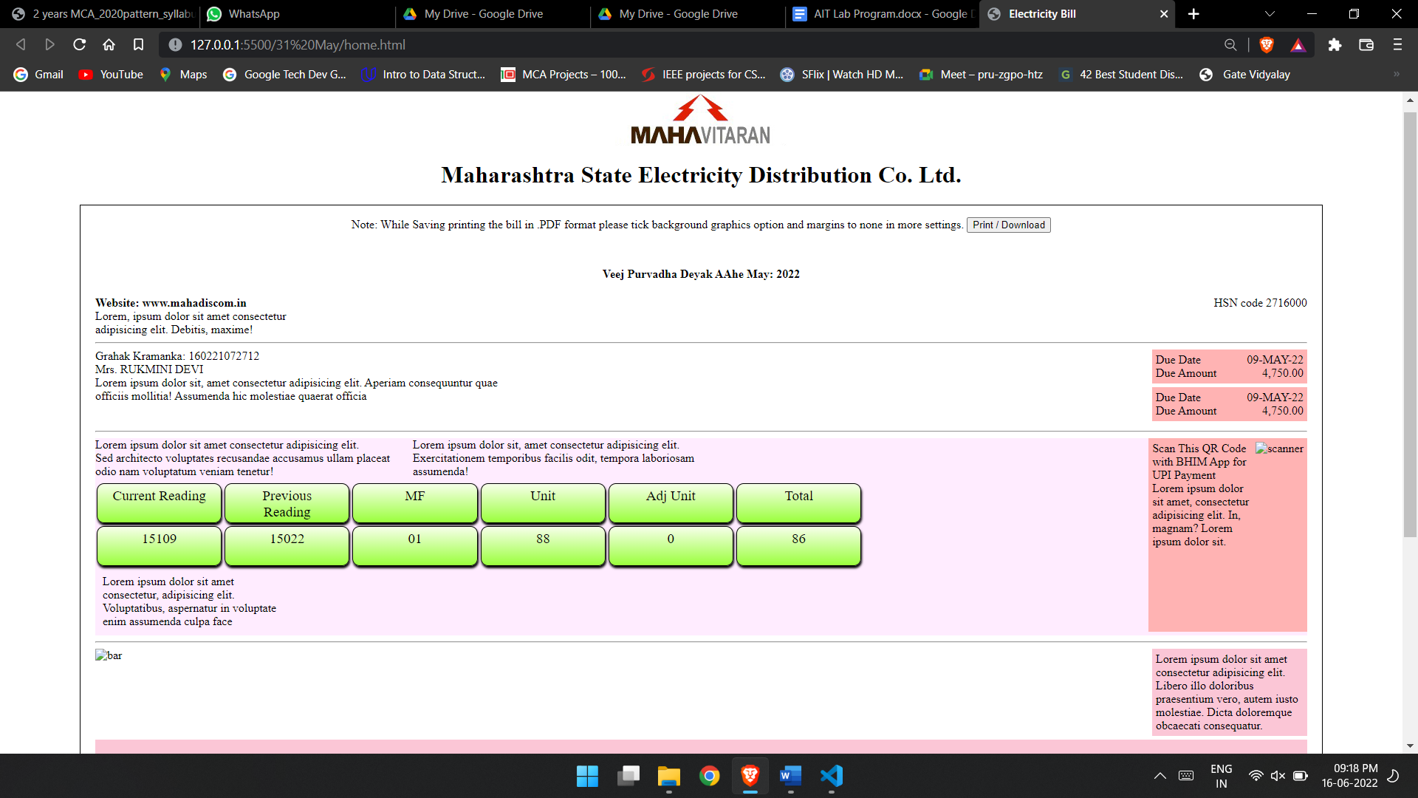

**Assignment 5:** Implement Transformation using Translation, Rotation and Scaling in your web page.

<!DOCTYPE html>

<html lang="en">

<head>

<meta charset="UTF-8">

<meta http-equiv="X-UA-Compatible" content="IE=edge">

<meta name="viewport" content="width=device-width, initial-scale=1.0">

<title>Animation</title>

<style>

#a1 {

height: 40px;

width: 70px;

position: relative;

animation-name: example;

animation-duration: 10s;

animation-delay: 2s;

animation-fill-mode: both;

}

@keyframes example {

0% {

top: 0px;

background-color: yellow;

}

25% {

top: 200px;

left: 0px;

background-color: blueviolet;

}

50% {

top: 200px;

left: 200px;

background-color: aqua;

}

75% {

top: 0px;

left: 200px;

background-color: azure;

}

100% {

top: 0px;

left: 0px;

background-color: cornflowerblue;

}

}

</style>

</head>

<body>

<div id="a1">

</div>

</body>

</html>

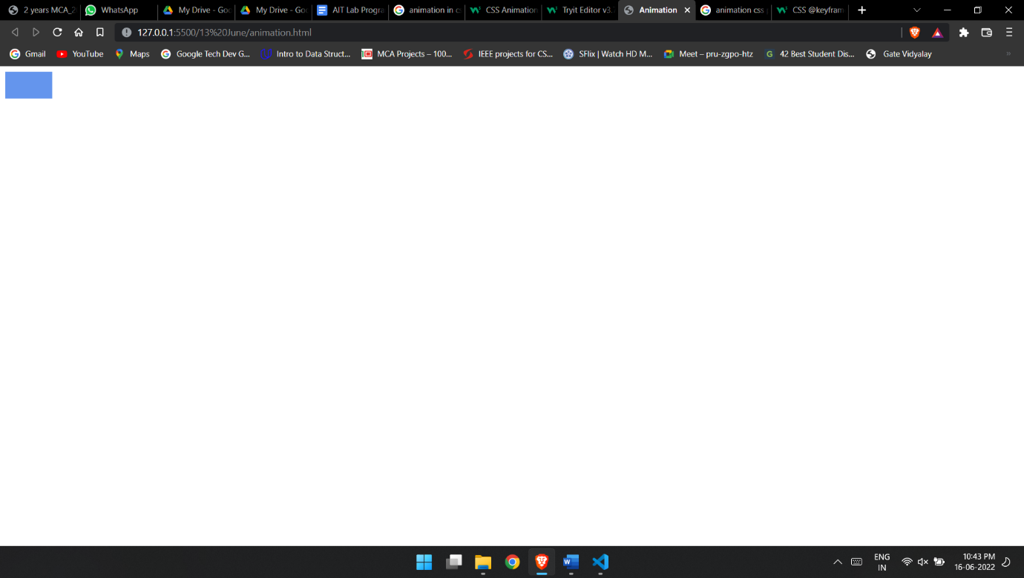

**Pattern:**

<!DOCTYPE html>

<html lang="en">

<head>

<meta charset="UTF-8">

<meta http-equiv="X-UA-Compatible" content="IE=edge">

<meta name="viewport" content="width=device-width, initial-scale=1.0">

<title>Pattern</title>

<script src="./pattern.js"></script>

</head>

<body>

<input type="text" id="p1"><input type="button" name="pattern1" value="Pattern 1" onclick="pattern1()"><br>

<div id="p1op"></div>

<input type="text" id="p2"><input type="button" name="pattern2" value="Pattern 2" onclick="pattern2()"><br>

<div id="p2op"></div>

<input type="text" id="p3"><input type="button" name="pattern3" value="Pattern 3" onclick="pattern3()"><br>

<div id="p3op"></div>

<input type="text" id="p4"><input type="button" name="pattern4" value="Pattern 4" onclick="pattern4()"><br>

<div id="p4op"></div>

<input type="text" id="p5"><input type="button" name="pattern5" value="Pattern 5" onclick="pattern5()">

<div id="p5op"></div>

</body>

</html>

Pattern.js

function pattern1() {

var n = 5, i, j;

n = document.getElementById('p1').value;

var op = "";

for (i = 1; i <= n; i++) {

for (j = 1; j <= i; j++) {

op += "* ";

}

op += "<br/>";

}

document.getElementById("p1op").innerHTML = op;

}

function pattern2() {

var n = 5, i, j;

n = document.getElementById('p2').value;

var op = "";

for (i = 1; i <= n; i++) {

for (j = 1; j <= (n - i); j++) {

op += "&nbsp;&nbsp;";

}

for (j = 1; j <= i; j++) {

op += "*";

}

op += "<br/>";

}

document.getElementById("p2op").innerHTML = op;

}

function pattern3() {

var n = 5, i, j;

n = document.getElementById('p3').value;

var op = "";

for (i = 1; i <= n; i++) {

for (j = 1; j <= (n - i); j++) {

op += "&nbsp;&nbsp;";

}

for (j = 1; j <= i; j++) {

op += "&nbsp;* ";

}

op += "<br/>";

}

document.getElementById("p3op").innerHTML = op;

}

function pattern4() {

var n = 5, i, j;

n = document.getElementById('p4').value;

var op = "";

for (i = 1; i <= n; i++) {

for (j = 1; j <= i; j++) {

op += "&nbsp;&nbsp;";

}

for (j = 1; j <= (n - i) + 1; j++) {

op += " *&nbsp;";

}

op += "<br>";

}

document.getElementById("p4op").innerHTML = op;

}

function pattern5() {

var n, i, j;

n = document.getElementById('p5').value;

var op = "";

for (i = 1; i <= n; i++) {

for (j = 1; j <= n; j++) {

if (j == Math.ceil(n / 2)) {

op += "#&nbsp;";

}

else if (j == i || j == (n - i + 1)) {

op += "*&nbsp;";

}

else {

op += "&nbsp;&nbsp;";

}

}

op += "<br/>";

}

var div = document.getElementById("p5op").innerHTML = op;

}

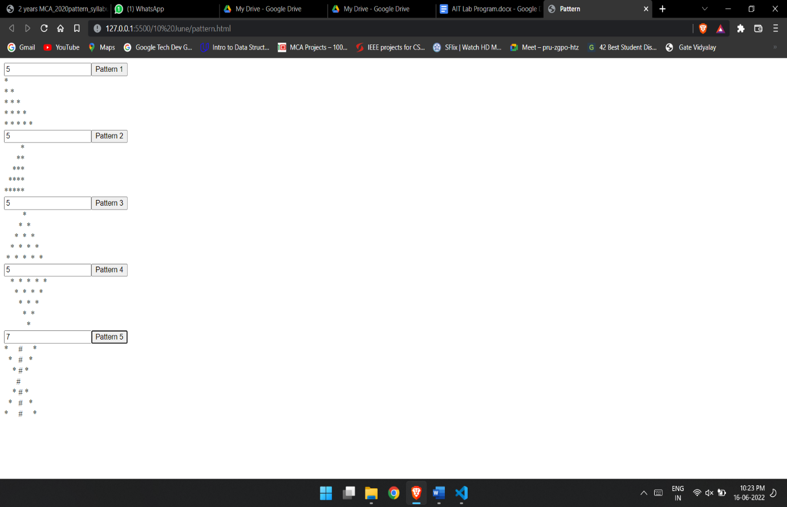

**Age checker.**

<!DOCTYPE html>

<html lang="en">

<head>

<meta charset="UTF-8">

<meta http-equiv="X-UA-Compatible" content="IE=edge">

<meta name="viewport" content="width=device-width, initial-scale=1.0">

<title>Document</title>

<style>

.container{

height: 50%;

width: 50%;

margin-right: auto;

margin-left: auto;

display: flex;

flex-direction: column;

padding-top: 200PX;

align-items: center;

}

input{

height: 30px;

width: 150px;

}

</style>

<script>

function check(){

var today = new Date()

var dob= document.getElementById("dob").value

dob= new Date(dob)

if(today.getFullYear()-dob.getFullYear()>18)

{

alert("You are eligible")

}

else{

alert("You are not eligible for voting")

}

}

</script>

</head>

<body>

<div class="container">

<input type="date" id="dob" /> <br>

<input type="button" value="check eligibility" onclick="check()">

</div>

</body>

</html>

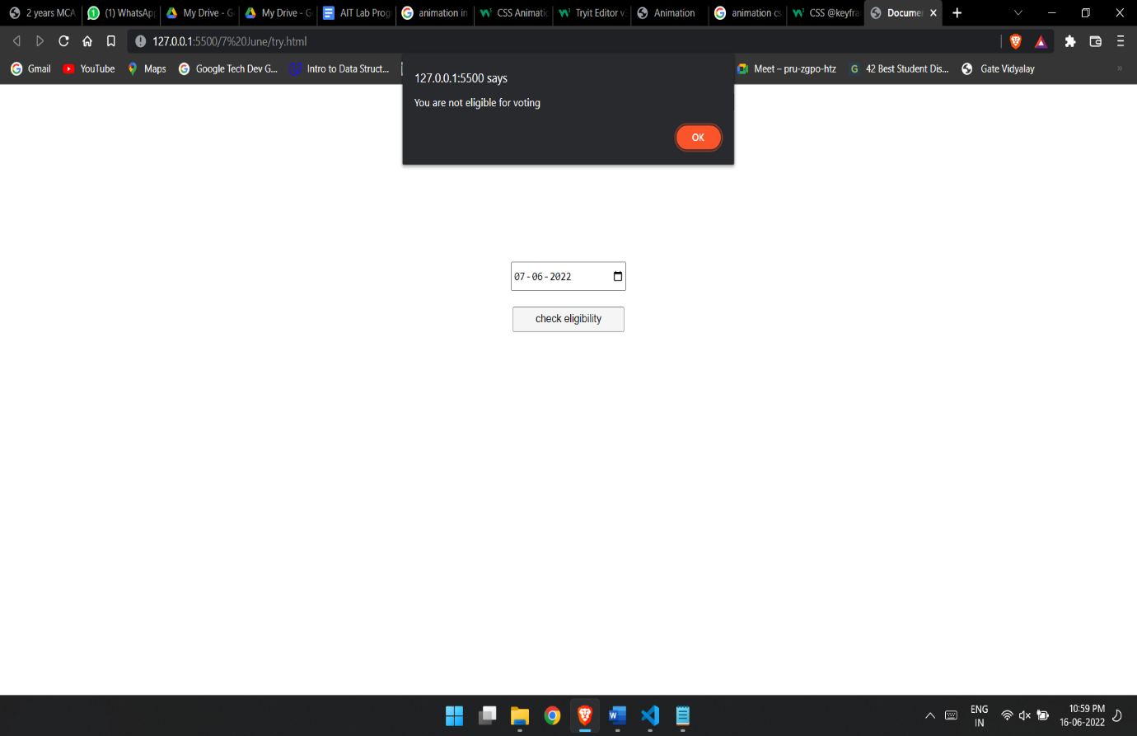

Test Q 2

<html>

<head>

<title>Animation and Transformation</title>

<style>

body {

display: flex;

justify-content: center;

flex-direction: row;

justify-content: space-around;

}

.scl {

height: 300px;

width: 300px;

border-radius: 50%;

background-color: red;

animation-name: animate;

animation-duration: 10s;

animation-delay: 1s;

animation-timing-function: ease-in;

animation-iteration-count: infinite;

}

.rot {

height: 300px;

width: 300px;

background-color: red;

animation-name: animate1;

animation-duration: 10s;

animation-delay: 1s;

animation-timing-function: ease-in;

animation-iteration-count: infinite;

}

@keyframes animate {

0% {

transform: scaleX(20%);

}

25% {

transform: scaleY(40%);

background-color: yellow;

}

50% {

transform: scaleX(60%);

background-color: blue;

}

75% {

transform: scaleX(80%);

background-color: pink;

}

100% {

transform: scaleY(100%);

background-color: green;

}

}

@keyframes animate1 {

0% {

transform: rotate(20deg);

}

25% {

transform: rotate(40deg);

background-color: yellow;

}

50% {

transform: rotate(60deg);

background-color: blue;

}

75% {

transform: rotate(80deg);

background-color: pink;

}

100% {

transform: rotate(100deg);

background-color: green;

}

}

</style>

</head>

<body>

<div class="scl"></div>

<div class="rot"></div>

</body>

</html>

